

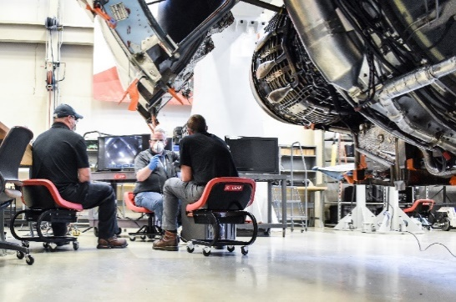
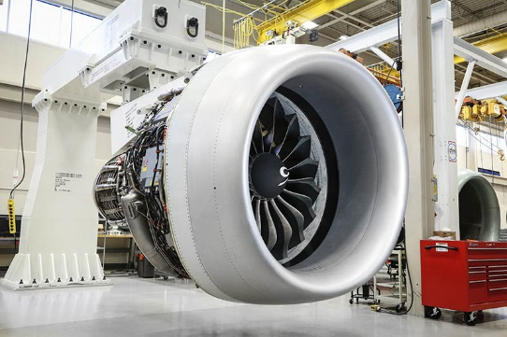

GE Aerospace
Customer Technical Education Center
Maintenance Training Catalog



Table of Contents
Table of Contents 2
History of GE 3
GE Customer Training Services 4
Global Footprint 5
ATA 104 Specifications 6
Services Offered 7
CTEC University Online Training Options 8
CTEC University (CTEC U) 9
Course and Service Matrix 11
GE Aerospace
CF6 Courses 12
CF34 Courses 14
GEnx Courses 16
GE90 Courses 18
GE9X-105B1A 20
HF120 Courses 22
Passport 23
Engine Condition Monitoring 25
Powerplant Engineering Course 26
CFM International
CFM Courses 28
LEAP Courses 29
Avionics and Electrical Power Systems
Boeing 777 ELMS 32
Boeing 737 FMS 33
Boeing 737 CCS 35
Boeing 787 EAFR, RIPS & AMP 35
COMAC 919 FMS 36
COMAC 919 OMS 37
COMAC 919 FRS 38
COMAC 919 FMS / FRS / OMS Level 1 39
ELMS 3 40
Boeing 777X CCS 41
Boeing 777X FRS 42
Boeing 777X Backup Electrical Power System 43
Boeing 777X & 787 IGS 44
Military Products Training 45
Contact Information 44


History of GE

From the first turbosupercharger to the world’s most powerful commercial jet engine, GE’s history of powering aircraft spans nearly a century of innovation.
GE Aerospace is a world-leading provider of commercial and military jet engines and components as well as integrated digital, electric power, and mechanical systems for aircraft. GE Aerospace also has a global service network to support these offerings.
Technological excellence, supported by continued investments in research and development, has been the foundation of GE Aerospace’s growth and helps to ensure quality products for customers well into the future.

Technology Innovation
- First U.S. Jet Engine
- First Turboprop Engine
- First Variable Stator Engine
- First Mach 2 Engine
- First High-Bypass Engine
- First Variable Cycle Turbofan Engine

- First Unducted Fan Engine
- First 30:1 Pressure Ratio Engine
- GE90-115B World Record -
steady state thrust: 127,900 lbs.
- GE9X-105B World Record -
steady state thrust: 134,300 lbs.
- Additive Manufacturing Processes

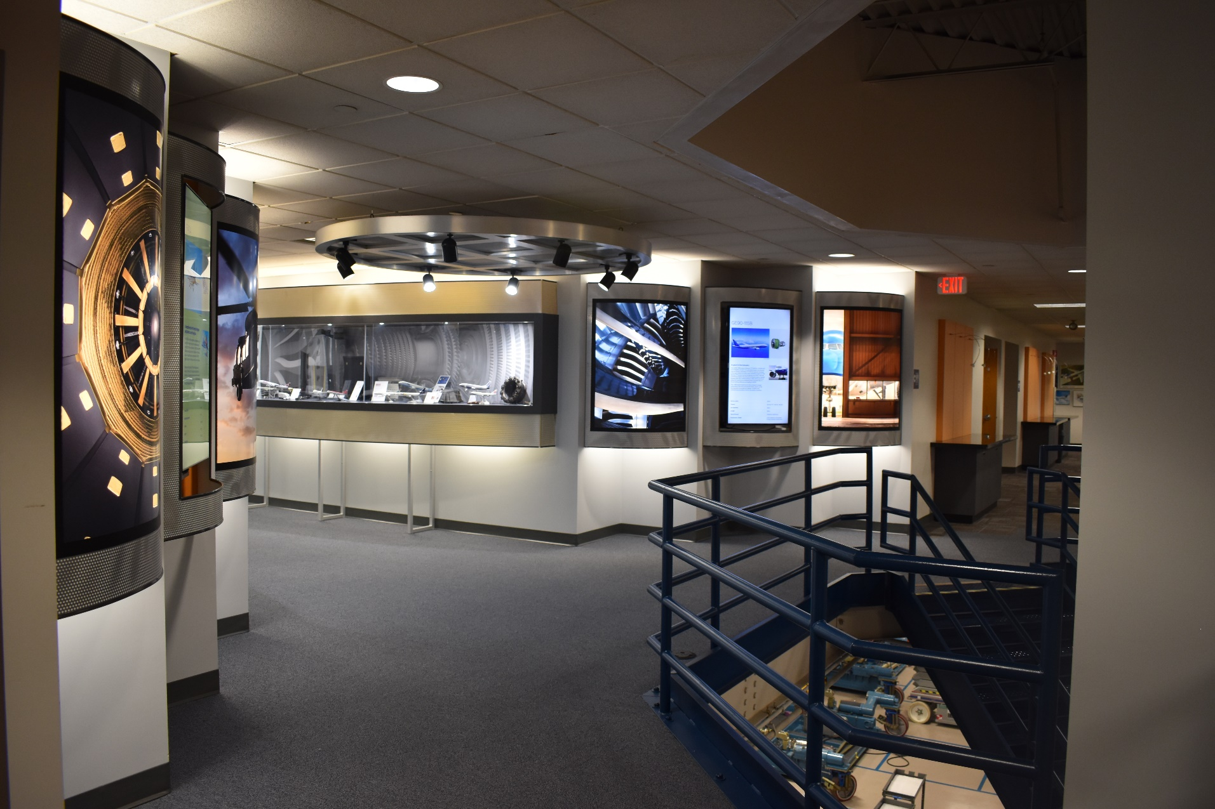

GE Customer Training Services

At the Customer Technical Education Center, our vision and goals focus on fulfilling the training needs of each customer by providing world-class training instructors and facilities to ensure that the most current technical information is available for each of our products. We strive to quickly respond to training needs on time and as expected – all with the end goal of improving engine reliability through state-of-the-art maintenance instruction.

Our promise is to continue to employ the most modern teaching methods using hands-on applications and instructions on products and tooling, while offering new and innovative digitized solutions to you – our customer.
Global Footprint

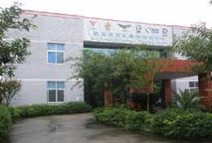

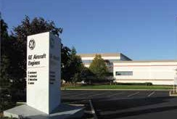

CTEC
The Customer Technical Education Center (CTEC) located just outside Cincinnati, Ohio, provides technical training to customer mechanics, powerplant engineers, GE employees, and other representatives daily to help ensure fleet reliability.

CTEC employs a staff of world-class engine training experts who deliver not only technical training, but also real-world application instructions for each of the GE and CFM engine programs, as well as GE Aerospace system components.

CTEC provides regular customer tours of the training facility as part of its support for customers. In addition, regular “Voice of the Customer” sessions are held to better understand customer training and technical needs.

On-site classes are also available to customers who desire a private course for a larger number of their mechanics.
AEMTC
The Aero Engine Maintenance Training Center (AEMTC) - a cooperative training institute comprised of Chinese partners, Safran Aircraft Engines, CFM International, and GE Aerospace - specializes in maintenance training for GE and CFM commercial aircraft engines.

Since 1996, the center has trained students from airlines throughout Asia. Located on the campus of the Civil Aviation Flight University of China (CAFUC), AEMTC is a two-story building containing six classrooms and a shop with ten training engines. There are eight instructors who conduct training classes for CFM56-3, CFM56-5B, CFM56-7B, CF34-10A, LEAP-1A, LEAP-1B, and LEAP-1C line maintenance, and borescope inspection.

AEMTC keeps close ties with the CFM training facilities at GE Aerospace (CTEC) and Safran Aircraft Engines (CTC) by sharing the same training materials, quality control measures and instructor best practices. AEMTC also keeps close contact with the GE/CFM Field Service team creating special training and seminars.
GE ATRC
The GE Advanced Technology & Research Center (GE ATRC) is located in Doha, Qatar, in the Middle East. This GE Aviation technical customer training facility is part of the Qatar Science & Technology Park within Education City.

The 13,400-square-meter (144,238-square-foot) facility includes six digital classrooms, as well as 14 engine/tooling bays for the “hands- on” portion of the technical learning offerings.

The facility opened in 2010 and features a full assortment of training on various engine models. Popular class offerings such as Line Maintenance, Borescope, and Engine Change are available to qualified customers.

Additional facility highlights:
• 490 square meters
(5,260 square feet) of lab space
• 150-seat auditorium
• 465-square-meter (5,000-square-foot) product display lobby

ATA 104 Specifications
All GE courses comply with ATA 104 Specifications

Level I – General Familiarization
Personnel must be familiar with current equipment and have general knowledge of turbine-powered transport aircraft. Level I provides a brief overview of the airframe, systems, and powerplant as outlined in the Systems Description section of the Aircraft Maintenance Manual.

Level II – Ramp and Transit
Personnel must be familiar with turbine-powered transport aircraft, digital electronic equipment, and have experience in ramp, transit, and turnaround activity. Level II provides a basic system overview – a description of controls, indicators, and principal components, including their locations and practical training on servicing and minor troubleshooting.

Level III – Line and Base Maintenance Training
In addition to requirements for Levels I and II, personnel attending Level III training should possess the knowledge and experience required to maintain turbine-powered transport aircraft. Level III provides a detailed description, operation, component location, removal/installation, BITE and troubleshooting procedures to maintenance manual level.

Level IV – Specialized Training
Personnel must have considerable experience in the field in which training will be received. Level IV provides a detailed description, component location, in-depth troubleshooting, adjustment, test procedures, rigging, engine run-up, in-depth use of wiring diagrams, schematics, and engineering data. Entry level is defined by subject matter.

Level V – Component Overhaul Training
Personnel must meet prerequisites established by the vendor. Specialized maintenance/overhaul training is conducted by airframe/engine/avionics manufacturers and/or their suppliers and/or airlines to a component maintenance manual level. Entry level is defined by subject matter.

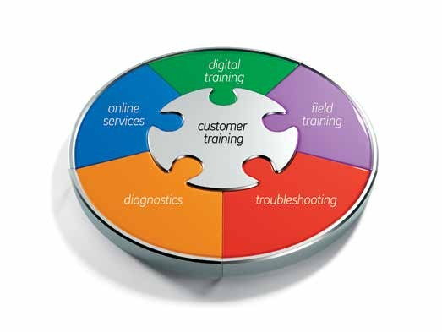
Services Offered

GE Aerospace’s Customer Training Team is constantly studying fleet data and adapting our classes to best suit our customer’s needs – your needs. Our team is committed to providing quality training to our customers to help reduce maintenance errors and improve fleet reliability. That is why we offer a complete curriculum of technical training courses on our products. Our philosophy is simple: Better maintenance practices reduce operation disruptions. So, it is no surprise that our courses are designed to simulate the environment in which you work and the real-world problems you encounter.

Classroom Training
Our courses provide the latest maintenance training for both engine and GE Aerospace system components. Courses range from an introductory level up to ATA level 4 training for commercial and military products. The academic portion of the course is provided in modern classrooms, and most courses include a hands-on portion providing practical experience to the mechanic. Our instructors share a wealth of academic and practical experience with discussions of common and not so common maintenance scenarios.

Virtual Training
Virtual training via Microsoft TEAMS allows customers to receive the academic portions of a traditional instructor-led class without the expense of traveling to one of our training centers or paying for an instructor to come to their site. Individual students log into a standard online collaborative meeting format to join the class. They receive the same technical information and have the same level of participation as if they attended class in person.


On-Site Customer Training
Under this program a CTEC instructor provides training and support beyond what is achievable in the classroom at the customer’s facility. This program is especially beneficial to customers introducing a new engine type into their fleet, as a GE expert can work with technicians on the flight line, answering questions and providing education on issues as they occur. Although the On-Site Customer training is primarily focused on Line Maintenance tasks, CTEC instructors can also provide guidance during Engine Changes and certain repairs. Contact CTEC.U@geaerospace.com for program availability and specific offerings.

Online Training Content
Our online training includes our Maintenance Minutes, Digital Training Aids (DTAs), Best Practices Documents, Maintenance Newsletters, and Engine General Familiarization self-paced courses. This
on-demand content is available 24x7 via CTEC University.

Troubleshooting
This two-day class will focus on the engine fault indications and troubleshooting logic using current fleet data to highlight the issues customers see most. Dedicated Troubleshooting classes are available on most engine lines. These courses are available upon request.

Translators
All classes and training material are presented in English. Additional class time may be required if a translator is needed. Please discuss any translation needs during class scheduling. Customers are responsible for supplying their own translators.


CTEC University Online Training Options

To meet the increasing customer demand for training and to help customers reduce costs, GE has developed on-demand, self-paced digital training products to deliver vital maintenance information directly to the maintainer available on our CTEC University website.

General Familiarization Courses
Electronic familiarization courses (eFam) introduce a specific engine model’s architecture and systems. This enables GE to provide genuine OEM training to eligible customers who do not have the opportunity to travel to our Training Centers. For most product lines, these courses are recommended prior to any subsequent training at our training centers.

Maintenance Minute (MXMs)
The CTEC team launched Maintenance Minute videos in 2015 to help customers prevent the most common issues with general engine line maintenance. The videos offer on-demand tips and best practice recommendations. The goal is for a mechanic to review the pertinent video prior to completing a prescribed maintenance task to avoid these errors.

Videos are available to everyone on GE Aerospace’s CTEC University website log in page at this URL https://training.geaerospace.com/ as well as on GE Aerospace’s YouTube channel.

Digital Training Aids (DTAs)
Digital Training Aids are designed to provide the mechanic with information about specific maintenance procedures that have been linked to critical issues. This interactive learning allows the user to view detailed procedures. The cautions surrounding critical steps are highlighted and summarized.

These videos contain proprietary data and are only available upon logging into GE Aerospace’s CTEC University website at the following URL: https://training.geaerospace.com/.

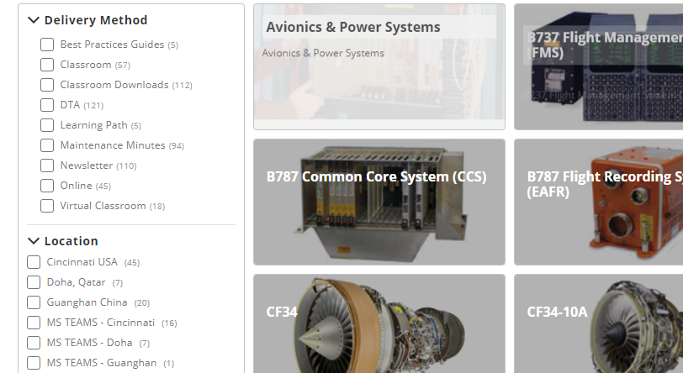
Course Menu in CTEC University

Best Practice Guides
Best Practice Documents are documents created by our engineers capturing all the latest best practices of a specific maintenance task. These documents are often published for the more difficult and lengthy maintenance tasks and provide mechanics with the most up-to-date information to prevent human factor issues and reduce the completion time for a maintenance task. Often these documents are published so maintainers have the information as soon as possible while more formal documentation such as service bulletins or aircraft or engine maintenance manuals are updated.

Maintenance Newsletters
Maintenance Newsletters provide a one or two-page summary of a current maintenance topic. The newsletters are initially released in the monthly engine model specific Fleet Highlites document and then provided in CTEC University for easy access.

**Online training and training material for GE’s customers will be available based on each customer’s General Terms Agreement (GTA)/contract rights.
TRAINING

CTEC University (CTEC U)

GE Aerospace’s maintenance training website (CTEC U) is a central online training site for GE’s customers and employees to obtain a full array of CTEC training and course materials.

For our customers, this site enables a “one-stop- shopping” experience with all training materials available to them, including general familiarization courses, newsletters, Maintenance Minute videos, DTA videos, online courses, course schedules, training records, etc.

In addition, increased access is provided to customer training coordinators allowing them to:

- Access training schedules
- Purchase training
- Register students for classes
- Substitute and cancel student registrations
- Review training records and training credits (if applicable)
- View remaining training credits

For more information or to nominate a training coordinator for your organization, please send your inquiry to CTEC.U@geaerospace.com or contact your GE Customer Support Manager.

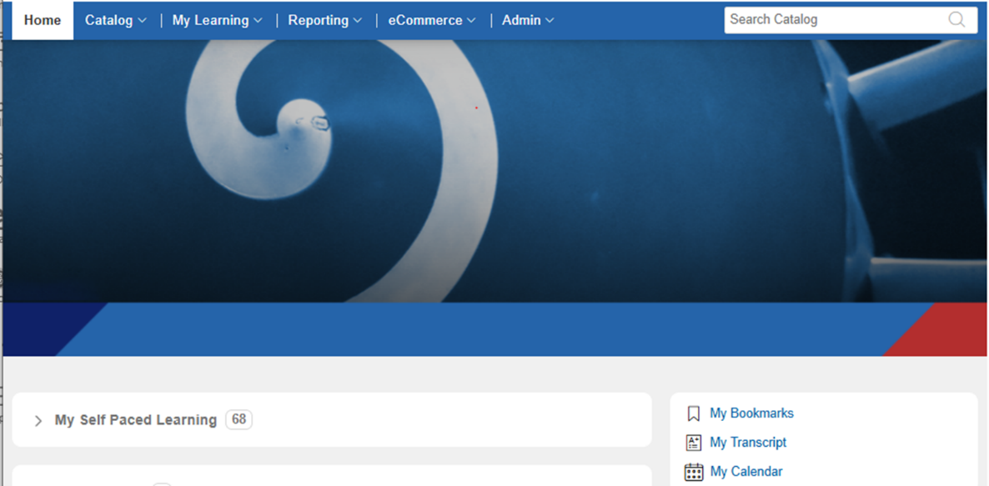
CTEC University Site – After Logging In

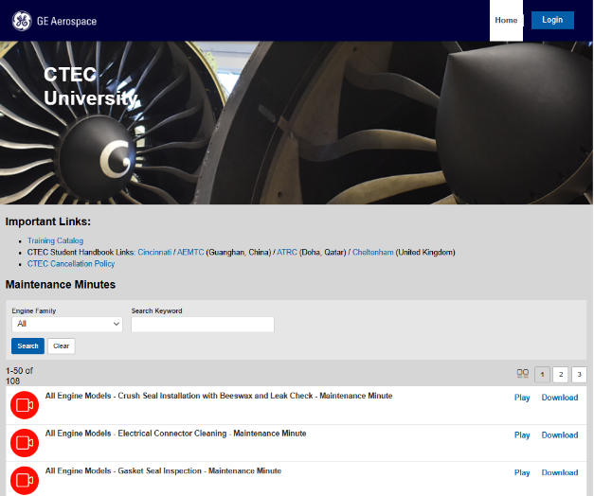
CTEC University (CTEC U)

Frequently Asked CTEC U Questions

Getting Access to CTEC University
CTEC University can be accessed directly from any of the customer portals (my.geaviation.com, mycfmportal, or mygehonda.com) by selecting training from the Links widget. Users may also log in from the direct link at this URL: https://training.geaerospace.com

Access to Training and Class Pricing
Training provisions (available training to your company) and payment terms are based upon your current license agreement(s). Please contact your Customer Support Manager, or CTEC (CTEC.U@geaerospace.com) should you require further details.

Individual class prices may be found by logging into CTEC University searching for the desired courses. Class prices are available for each course.

Options to Enrolling Students in a Couse
- Self-Service Opportunity for Customer Training Coordinators
If your organization has someone responsible for training, we can grant them Training Coordinator privileges to CTEC University (CTEC U). These additional privileges allow the coordinator to view schedules, purchase seats in courses, register students for class, substitute students, print student certificates, view student records, and access reports to track your company student’s training records.
- Email Requests to CTEC U
Company representatives may send training requests and/or student registration requests to CTEC.U@geaerospace.com and we can enroll your students.

All other training inquiries that are not processed through an organization’s Training Coordinator can be directed to CTEC at CTEC.U@geaerospace.com or your GE Customer Support Manager.

Additional Notes
- Enrolling students requires the following information: student name, organization, company email and nationality. If the student has a GE SSO to log into the customer portals, that should be provided with the training request.

- If your organization is paying via a Purchase Order, this PO must be received by CTEC before enrollment and seats in class will be secured. Invoicing for class occurs after the last class date, and all payment terms are net 30 days from invoice receipt.

Course and Service Matrix

Engine Model(s) | General  Familiarization | Line  Maintenance | Borescope  Inspection | Borescope  Blade  Blend | Engine  Removal & Installation | Fan Stator  Removal & Installation | Thrust  Reverser | Intermediate Maintenance
CFM56-2/F108 | • | • | • | •
CFM56-3 | • | • | • | •
CFM56-7 | • | • | • | • | •
CF34-3 | • | • | •
CF34-8C | • | • | • |  | •
CF34-8E | • | • | • |  | •
CF34-10A (AEMTC only) | • | • | •
CF34-10E | • | • | • |  | •
CF6-80C2 PMC |  | • | • | • |  |  | •
CF6-80C2 FADEC | • | • | • | • |  |  | •
GE90-115B | • | • | • | • |  | •
GENX-1B | • | • | • | • | • | •
GENX-2B | • | • | • | • | • | •
GE9X-105B1A | • | • | • | • | • | •
Honda HF120 | • | • | •
LEAP-1A | • | • | • | • | •
LEAP-1B | • | • | • | • | •
LEAP-1C (AEMTC only) | • | • | • | • | •
Passport | • | • | • |  | •

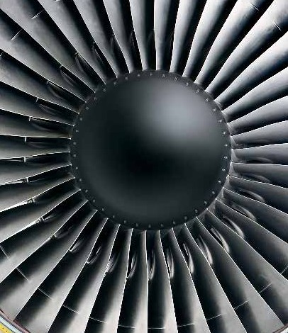

CF6®

For more than 50 years the CF6 family of engines has established an impressive operational record, providing a baseline for developing GE’s next generation of commercial and military engines. The CF6 family is the cornerstone for powering widebody aircraft across the globe.

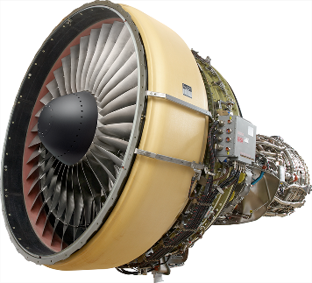
Engine
CF6 Courses

CF6 General Familiarization
ATA 104 Level Level I
Prerequisites: None
Course Length: 4 hours
In Class Option: N/A
Virtual Option: N/A
This course is available online at the CTEC University website and is a prerequisite to be completed at the student’s home base before attending Line Maintenance. This course is an academic training session designed for personnel who require a general knowledge of the basic engine construction features, airflows, engine systems, and accessories.

CF6 Line Maintenance
ATA 104 Level Level III
Prerequisites: General Familiarization
In Class Option (4 days): Yes
Virtual Option (varies): Yes
Class Size: 6-12 students
This course is an academic and practical training session designed for line maintenance mechanics and supervisory personnel with high-bypass engine and English language experience. The course consists of specific academic information on engine airflows, engine systems, component identification, and fault analysis. The hands-on portion of this course consists of removal and replacement of select engine components and use of maintenance manuals.

CF6 Borescope Inspection
ATA 104 Level Level IV
Prerequisites: Basic Borescope
In Class Option (2 day) Yes
Virtual Option N/A
Class Size: 3-6 students
This course is an academic and practical training session designed for line maintenance mechanics and supervisory personnel. The course consists of specific academic information to analyze internal engine defects. The hands-on portion of this course consists of removal and replacement of engine borescope plugs, use of borescope equipment, and use of maintenance manuals.

CF6 Borescope Blade Blend*
ATA 104 Level Level IV
Prerequisites: Borescope Inspection experience
In Class Option (2 days): Yes
Virtual Option: N/A
Class Size: 3-5 students
This course is an academic and practical training session designed for line maintenance technicians and supervisory personnel. Subject matter will include blade blend procedures, use of borescope blend equipment, and application of the maintenance manual for the CF6 series engines.

*This course must be purchased at the current training rate, or training entitlements may be used at a three times (3X) rate if training entitlements are available to the customer.



CF34®

Aircraft readiness, on-time departures, reliability, flexibility, and cost-effective operation are all important measures of a successful regional aircraft engine.

The CF34 family delivers on all fronts with the most reliable engine in the history of regional aviation. The CF34 engines also provide the power for business jet service on the Bombardier Challenger 604/605 aircraft and Embraer lineage aircraft.

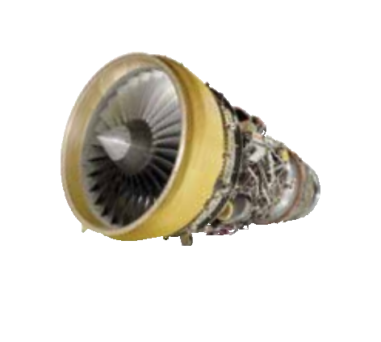
CF34 Courses

CF34 General Familiarization
ATA 104 Level Level I
Prerequisites: None
Course Length: 4 hours
In Class Option: N/A
Virtual Option: N/A
This course is available online on the CTEC University website and is a prerequisite to be completed at the student’s home base before attending Line Maintenance. This course is an academic training session designed for personnel who require a general knowledge of the basic engine construction features, airflows, engine systems, and accessories.

Available in the following engine models:
CF34-3 / CF34-8C / CF34-8E / CF34-10A / CF34-10E

CF34 Line Maintenance and Engine Removal/Installation
ATA 104 Level Level III
Prerequisites: General Familiarization
In Class Option (4 days): Yes
Virtual Option (varies): Yes
Class Size: 6-12 students
This course is an academic and practical training session designed for line maintenance mechanics and supervisory personnel with high-bypass engine and English language experience. The course consists of specific academic information on engine airflows, engine systems, component identification, and fault analysis. The hands-on portion of this course consists of removal and replacement of select engine components and use of maintenance manuals.

Available for the following engine models:
CF34-3 / CF34-8C / CF34-8E / CF34-10A / CF34-10E

CF34 Engine Removal and Installation
ATA 104 Level Level IV
Prerequisites: General Familiarization
In Class Option (1 days): Yes
Virtual Option (varies): Yes
Class Size: 6-12 students
This course is an academic and practical training session designed to train Line Maintenance personnel in how to remove and install a CF34 engine.

Available for the following engine models:
CF34-8C / CF34-8E / CF34-10E

CF34 Borescope Inspection
ATA 104 Level Level IV
Prerequisites: Basic Borescope
In Class Option (2 days) Yes
Virtual Option N/A
Class Size: 3-6 students
This course is an academic and practical training session designed for line maintenance mechanics and supervisory personnel.

Available in the following engine models:
CF34-3 / CF34-8C / CF34-8E / CF34-10A / CF34-10E

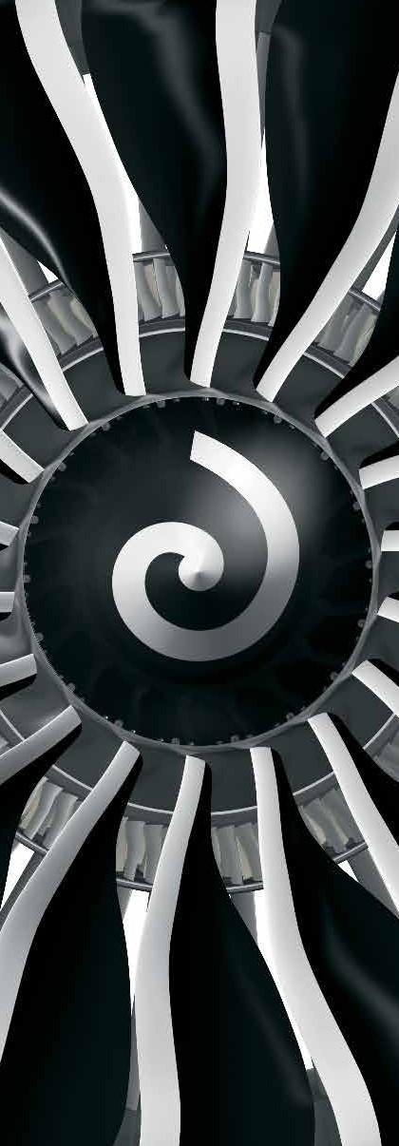

GENX™

A culmination of more than 60 years of inspired engine design, the GEnx turbofan engine refines the best technologies and systems of our most successful family members, the GE90 and CF6 engines. Designed to power a new generation of aircraft, the GEnx has evolved from a strong heritage of ingenuity, commitment, and dedication to excellence. The GEnx is making its mark in our proud legacy of aviation history.

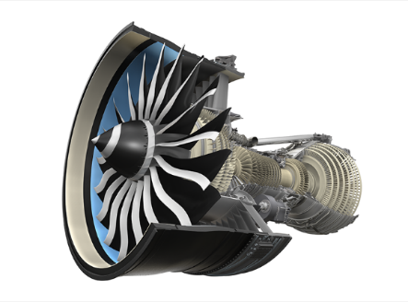
GEnx Courses

GEnx-1B / -2B General Familiarization
ATA 104 Level Level I
Prerequisites: None
Course Length: 4 hours
In Class Option: N/A
Virtual Option: N/A
This course is available online at the CTEC University website and is a prerequisite to be completed at the student’s home base before attending Line Maintenance. This course is an academic training session designed for personnel who require a general knowledge of the basic engine construction features, airflows, engine systems, and accessories.

GEnx-1B / -2B Line & Base Maintenance
ATA 104 Level Level III
Prerequisites: General Familiarization
In Class Option (5 days): Yes
Virtual Option (varies): Yes
Class Size: 6-12 students
This course is an academic and practical training session designed for line maintenance mechanics and supervisory personnel with high-bypass engine, and English language experience. The course consists of specific academic information on engine airflows, engine systems, component identification, and fault analysis. The hands-on portion of this course consists of removal and replacement of select engine components and use of maintenance manuals.

GEnx-1B / -2B Borescope Inspection
ATA 104 Level Level IV
Prerequisites: Basic Borescope
In Class Option (1 day): Yes
Virtual Option N/A
Class Size: 3-6 students
This course is an academic and practical training session designed for line or shop personnel responsible for borescoping the engine.

GEnx-1B / -2B Engine Removal & Installation
ATA 104 Level Level IV
Prerequisites: NA
In Class Option (2 days): Yes
Virtual Option: N/A
Class Size: mandatory 6-12 students
This course is an academic and practical training session designed to train Line Maintenance personnel how to remove and install a GEnx engine.

GEnx-1B / -2B Fan Stator Removal & Installation
ATA 104 Level Level IV
Prerequisites: NA
In Class Option (3 days): Yes
Virtual Option: N/A
Class Size: mandatory 6-12 students
This course is an academic and practical training session designed to train Line Maintenance personnel how to remove and install the GEnx engine and Fan Stator.

GEnx-1B / -2B Borescope Blade Blend*
ATA 104 Level Level IV
Prerequisites: Borescope Inspection experience
In Class Option (2 days): Yes
Virtual Option: N/A
Class Size: 3-6 students
This course is an academic and practical training session designed for line maintenance technicians and supervisory personnel. Subject matter will include blade blend procedures, use of borescope blend equipment, and application of the maintenance manual for the GEnx series engines.

*This course must be purchased at the current training rate, or training entitlements may be used at a three times (3X) rate if training entitlements are available to the customer.

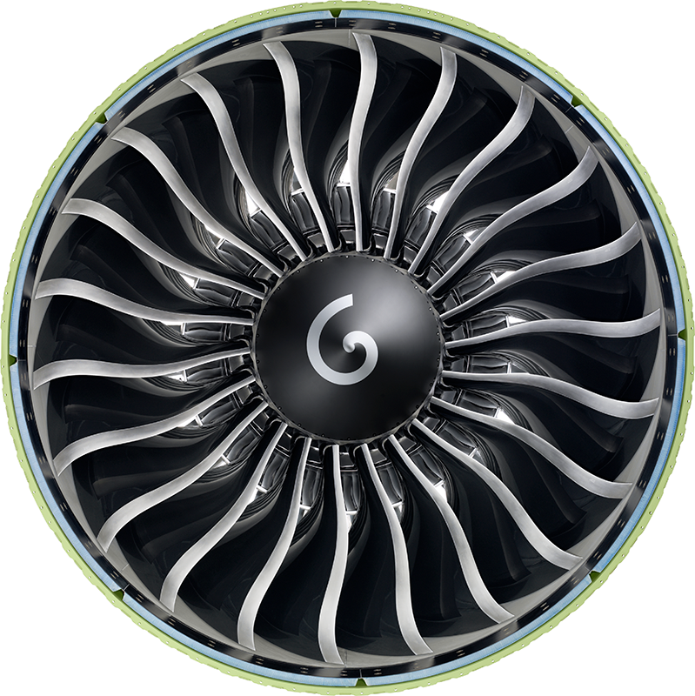

GE90®

Advanced, reliable, and efficient, the
GE90-115B consistently demonstrates operational reliability with highly developed propulsion technology infused in every feature of the engine. The GE90-115B is helping long-haul, long-range widebody aircraft fly farther, faster, and more cost effectively.

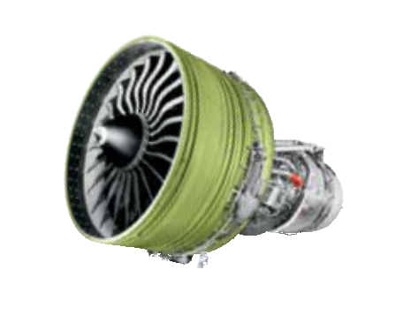
GE90 Courses

GE90 General Familiarization
ATA 104 Level Level I
Prerequisites: None
Course Length: 4 hours
In Class Option: N/A
Virtual Option: N/A
This course is available online at the CTEC University website and is a prerequisite to be completed at the student’s home base before attending Line Maintenance. This course is an academic training session designed for personnel who require a general knowledge of the basic engine construction features, airflows, engine systems, and accessories.

GE90 Line Maintenance
ATA 104 Level Level III
Prerequisites: General Familiarization
In Class Option (5 days): Yes
Virtual Option (varies): Yes
Class Size: 6-12 students
This course is an academic and practical training session designed for line maintenance mechanics and supervisory personnel with high-bypass engine and English language experience. The course consists of specific academic information on engine airflows, engine systems, component identification, and fault analysis. The hands-on portion of this course consists of removal and replacement of select engine components and use of maintenance manuals.

GE90 Borescope Inspection
ATA 104 Level Level IV
Prerequisites: Basic Borescope
In Class Option (2 days): Yes
Virtual Option N/A
Class Size: 3-6 students
This course is an academic and practical training session designed for line maintenance mechanics and supervisory personnel. The course consists of specific academic information to analyze internal engine defects. The hands-on portion of this course consists of removal and replacement of engine borescope plugs, use of borescope equipment, and use of maintenance manuals.

GE90 Engine Removal & Installation
ATA 104 Level Level IV
Prerequisites: NA
In Class Option (2 days): Yes
Virtual Option: N/A
Class Size: mandatory 6-12 students
This course is an academic and practical training session designed to train Line Maintenance personnel how to remove and install a GE90 engine.

GE90 Fan Stator Removal & Installation
ATA 104 Level Level IV
Prerequisites: NA
In Class Option (3 days): Yes
Virtual Option: N/A
Class Size: mandatory 6-12 students
This course is an academic and practical training session designed to train Line Maintenance personnel how to remove and install the GE90 engine and fan stator.

GE90 Borescope Blade Blend*
ATA 104 Level Level IV
Prerequisites: Borescope Inspection experience
In Class Option (2 days): Yes
Virtual Option: N/A
Class Size: 3-5 students
This course is an academic and practical training session designed for line maintenance technicians and supervisory personnel. Subject matter will include blade blend procedures, use of borescope blend equipment, and application of the maintenance manual for the GE90 series engines.

*This course must be purchased at the current training rate, or training entitlements may be used at a three times (3X) rate if training entitlements are available to the customer.

The GE9X is the world’s largest and most powerful commercial aircraft engine. It incorporates GE Aerospace’s most advanced technologies that have been developed over the last decade to make it the most fuel-efficient engine in its class while also delivering unmatched performance. The GE9X is the sole-sourced engine for the Boeing 777X family.
GE9X-105B1A



GE9X-105B1A Courses

GE9X-105B1A General Familiarization
ATA 104 Level: Level I
Prerequisites: None
Course Length: 4 hours
In Class Option: N/A
Virtual Option: N/A

This course is available online at the CTEC University website and is a prerequisite for Line Maintenance. This course is an academic training session designed for personnel who require a general knowledge of the basic engine construction features, airflows, engine systems, and accessories.

GE9X-105B1A Line & Base Maintenance
ATA 104 Level: Level III
Prerequisites: General Familiarization
In Class Option (5 days): Yes
Virtual Option (varies): Yes
Class Size: 6-12 students

This course is an academic and practical training session designed for line maintenance mechanics and supervisory personnel with high-bypass engine, and English language experience. The course consists of specific academic information on engine airflows, engine systems, component identification, and fault analysis. The hands-on portion of this course consists of removal and replacement of select engine components and use of maintenance manuals.

GE9X-105B1A Borescope Inspection
ATA 104 Level: Level IV
Prerequisites: Basic Borescope
In Class Option (1 day): Yes
Virtual Option: N/A
Class Size: 3-6 students

This course is an academic and practical training session designed for line or shop personnel responsible for performing gas path inspection of the engine.
GE9X-105B1A Engine Removal & Installation (Bootstrap or Hydro Cobra system)
ATA 104 Level: Level IV
Prerequisites: NA
In Class Option (2 days): Yes
Virtual Option: N/A
Class Size: mandatory 6-12 students

This course is an academic and practical training session designed to train Line Maintenance personnel how to remove and install a GE9X engine with the bootstrap or Cobra engine change system.

GE9X-105B1A Fan Stator Removal & Installation
ATA 104 Level: Level IV
Prerequisites: NA
In Class Option (3 days): Yes
Virtual Option: ........N/A
Class Size: mandatory 6-8 students

This course is an academic and practical training session designed to train Line Maintenance personnel how to remove and install the GE9X engine and Fan Stator.

GE9X-105B1A Borescope Blade Blend*
ATA 104 Level: Level IV
Prerequisites: Borescope Inspection experience
In Class Option (2 days): Yes
Virtual Option: N/A
Class Size: 3 students max

This course is an academic and practical training session designed for line maintenance technicians and supervisory personnel. Subject matter will include blade blend procedures, use of borescope blend equipment, and application of the maintenance manual for the GE9X-series engines.

*This course must be purchased at the current training rate, or training entitlements may be used at a three times (3X) rate if training entitlements are available to the customer.

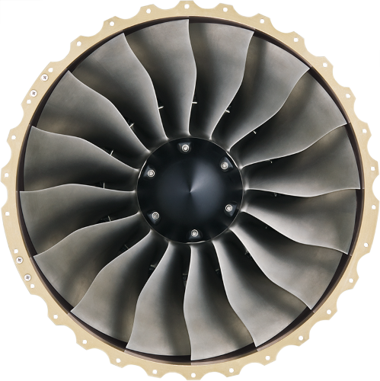

HF120

Born from the combined experience and technological proficiency of GE and Honda, the Honda HF120 turbofan engine from GE Honda Aero Engines sets the stage for next-generation business jet power.

The Honda HF120 was engineered with a determined and well-defined goal: anticipate and fulfill the future needs of business jets. Today, the Honda HF120 demonstrates enhanced efficiency and power across all levels of performance.

GE Honda HF120 General Familiarization
ATA 104 Level Level I
Prerequisites: None
Course Length: 4 hours
In Class Option: N/A
Virtual Option: N/A
This course is available online at the CTEC University website and is a prerequisite to be completed at the student’s home base before attending Line Maintenance. This course is an academic training session designed for personnel who require a general knowledge of the basic engine construction features, airflows, engine systems, and accessories.

GE Honda HF120 Line Maintenance
ATA 104 Level Level III
Prerequisites: General Familiarization
In Class Option (4 days): Yes
Virtual Option (varies): Yes
Class Size: 6-12 students
This course is an academic and practical training session designed for line maintenance mechanics and supervisory personnel with high-bypass engine experience. The course consists of specific academic information on engine airflows, engine systems, component identification, and fault analysis. The hands-on portion of this course consists of removal and replacement of select engine components and use of maintenance manuals.

GE Honda HF120 Borescope Inspection
ATA 104 Level Level IV
Prerequisites: Basic Borescope
In Class Option (1/2 day) Yes
Virtual Option N/A
Class Size: 3-6 students
This course is an academic and practical training session designed for line or shop personnel responsible for borescoping the engine.

GE Honda HF120 Engine Removal & Installation
ATA 104 Level Level IV
Prerequisites: None
In Class Option (1/2 day) Yes
Virtual Option N/A
Class Size: 3-8 students
This course is an academic and practical training session designed to train Line Maintenance personnel how to remove and install a HF120 engine.
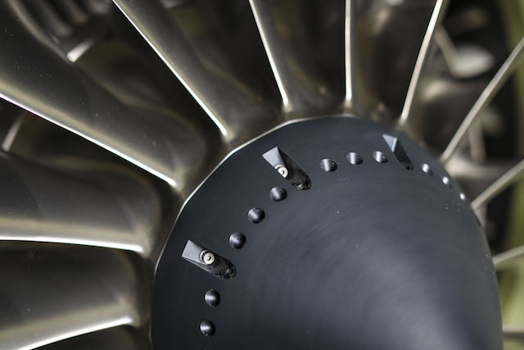

Passport TM

Using technology perfected on various GE engine platforms, the Passport’s performance surpasses any other engine in its class. Not only does the Passport enable ultra-long-range travel including powering the largest business jet, its reduced noise and lower emissions contribute to an optimal experience for both operators and passengers.

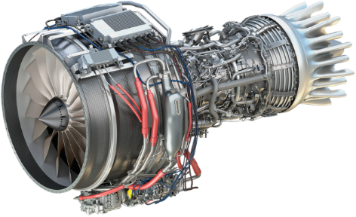
Passport 20 Courses
Passport 20 General Familiarization
ATA 104 Level Level I
Prerequisites: None
Course Length: 4 hours
In Class Option: N/A
Virtual Option: N/A
This course is available online at the CTEC University website and is a prerequisite to be completed at the student’s home base before attending Line Maintenance. This course is an academic training session designed for personnel who require a general knowledge of the basic engine construction features, airflows, engine systems, and accessories.

Passport 20 Powerplant Line & Base Maintenance
ATA 104 Level Level III
Prerequisites: General Familiarization
In Class Option (4 days): Yes
Virtual Option (varies): Yes
Class Size: 6-12 students
This course is an academic and practical training session designed for line maintenance mechanics and supervisory personnel with high-bypass engine and English language experience. The course consists of specific academic information on engine airflows, engine systems, component identification, and fault analysis. The hands-on portion of this course consists of removal and replacement of select engine components and use of maintenance manuals.

Passport 20 Borescope Inspection
ATA 104 Level Level IV
Prerequisites: Basic Borescope
In Class Option (3 day) Yes
Virtual Option N/A
Class Size: 3-6 students
This course provides the information necessary to understand the basic borescope inspection of the Passport engine. This course is recommended for borescope inspectors and quality personnel.

Passport 20 Borescope Blade Blend*
ATA 104 Level Level IV
Prerequisites: Borescope Inspection experience
In Class Option (1 day): Yes
Virtual Option: N/A
Class Size: 3-5 students
This course is an academic and practical training session designed for line maintenance technicians and supervisory personnel. Subject matter will include blade blend procedures, use of borescope blend equipment, and application of the maintenance manual for the Passport engines.

Passport 20 Fan Blisk Removal & Replacement
ATA 104 Level Level IV
Prerequisites: None
In Class Option (2 day): Yes
Virtual Option: N/A
Class Size: 12 students
This course is an academic and practical training session designed to train Line Maintenance personnel how to remove and install the Passport 20 Fan Blisk.

Passport 20 Engine Change
ATA 104 Level Level IV
Prerequisites: None
In Class Option (2 day): Yes
Virtual Option: N/A
Class Size: 12 students
This course is an academic and practical training session designed to train Line Maintenance personnel how to remove and install a Passport 20 engine.

*This course must be purchased at the current training rate, or training entitlements may be used at a three times (3X) rate if training entitlements are available to the customer.

Engine Condition Monitoring*

ATA 104 Level Level IV
Prerequisites: None
Course Length: 2 days
In Class Option: (2 days) Yes
Virtual Option: (4 days) Yes
Class Size: 6-20 students

GE Aerospace Fleet Support offers Engine Condition Monitoring training that teaches participants how key engine systems operate and how to monitor them using a customized suite of digital tools. Developed in collaboration with multiple GE customers, these tools are designed to integrate seamlessly into an operator’s existing work environment and processes.

This two-day course gives participants a solid understanding of the fundamental theory and operation of the engine systems from which diagnostic data is collected. It includes hands-on training with the Engine Condition Monitoring tool suite and builds practical skills in trend interpretation and its application to line maintenance troubleshooting.

The course outline is as follows:

Day 1: Engine Condition Monitoring Engine Systems and Theory

- Data Acquisition & Transfer: Data collection methods
- Data Analysis – Terminology: Key terms and definitions
- Performance Monitoring: Engine performance analysis
- Derate Monitoring: Understanding engine derates
- Vibration Monitoring: Vibration analysis techniques
- Oil System Monitoring: Oil system health assessment
- ETOPS Monitoring: Extended operations requirements
- Divergence: Engine-to-engine analysis

- Trend Analysis Principles: Trending methodologies
- Diagnostic Alerts: Alert logic and management
- Customer Notification Reports: CNR process and procedures

Day 2: Engine Trend Interpretation

- Digital Diagnostic Tools: Customer portals and Fleet Monitor X, including Data Query, Engine Change and other portal tools

- Supplemental Material: Additional resources

- CTEC Tour (In person only): Facility tour

Note:
For the Virtual 4-day session, the material is broken down to fill shorter class periods. The order of the material is the same; however, students are encouraged to sign up for the in-person course since this provides an improved learning experience and the CTEC tour.
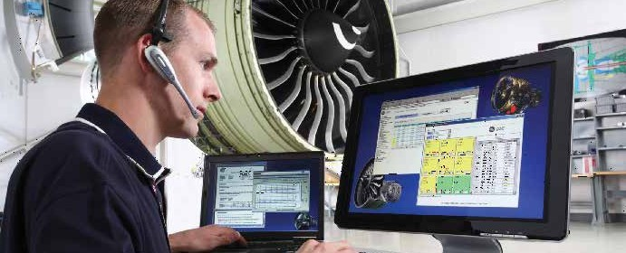

*This course must be purchased at the current training rate, or training entitlements may be used at a three times (3X) rate if training entitlements are available to the customer

Powerplant Engineering Course*

The course goal is to provide the student with basic knowledge of mechanical, aero, control, and systems design, and how the resulting engine hardware/ system performs in fielded service. In the course, GE design and analysis experts in their field discuss the common and unique design features and philosophies of GE and CFM aircraft engines.

Areas of discussion include the following

- Preliminary Engine Design
- Fan and Compressor Aero Design
- Fan and Compressor Mechanical Design
- Combustor Aero Design
- Static Structures Design
- Turbine Aero and Cooling Design
- Turbine Mechanical Design
- Mechanical systems Design
- External Mechanical Design
- Systems Effects
- Controls
- Performance
- Operability
- Human Factors Engineering

There are two discussion topics on specific engine management practices:

- Life Management
- Diagnostics and Prognostics
There is also a historical discussion of the evolution of the turbine engine:

- The Whittle Unit to the Ultra-High-Bypass Engine is discussed during this course. Topics are not specific to a particular engine model and include, but are not limited to, the CT7, CF6, CFM56, CF34, CFE738, GE90, GP7000, GEnx and competitor’s engines.

The discussion leaders are all experienced leaders in the technical field in which they lecture. These lectures include experts from GE in the following disciplines.

- Fleet Support / Product Support Engineering
- Systems Engineering
- Design Engineering
- Chief Engineer’s Office

Class size is tailored to customer demand, and the course is typically conducted twice a year during the September-to-November time frame.

* This course must be purchased at the current training rate. Training credits may not be used for this course.

CFM International

CFM International serves today as the finest example of a successful international joint company. The CFM family of engines combines the resources, engineering expertise, and services of Safran and GE Aerospace.

CFM’s rugged single-stage architecture is the most durable and efficient in the enabled CFM to emerge as the preferred engine in every market it serves.



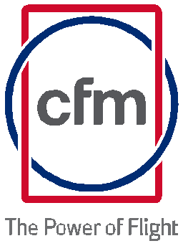
CFM International is a 50/50 joint company between GE and Safran.

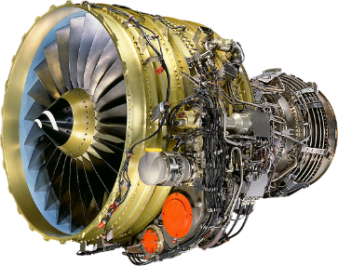
CFM56 Courses

CFM56 General Familiarization
ATA 104 Level Level I
Prerequisites: None
Course Length: 4 hours
In Class Option: 1 day at AETMC only
Virtual Option: N/A
This course is available online on the CTEC University website and is a prerequisite to be completed at the student’s home base before attending Line Maintenance. This course is an academic training session designed for personnel who require a general knowledge of the basic engine construction features, airflows, engine systems, and accessories.
Available in the following engine models:
CFM56-2, CFM56-3, CFM56-5, CFM56-7

CFM56 Powerplant Line & Base Maintenance
ATA 104 Level Level III
Prerequisites: General Familiarization
In Class Option (4 days): Yes
Virtual Option (3 days): Yes
Class Size: 6-12 students
This course is an academic and practical training session designed for line maintenance mechanics and supervisory personnel with high-bypass engine and English language experience. The course consists of specific academic information on engine airflows, engine systems, component identification, and fault analysis. The hands-on portion of this course consists of removal and replacement of select engine components and use of maintenance manuals.
Available in the following engine models:
CFM56-2, CFM56-3, CFM56-7
CFM56-5B Academic presentation only

*This course must be purchased at the current training rate, or training entitlements may be used at a three times (3X) rate if training entitlements are available to the customer
CFM56 Borescope Inspection
ATA 104 Level Level IV
Prerequisites: Basic Borescope
In Class Option (2 day) Yes
Virtual Option N/A
Class Size: 3-6 students
This course provides the information necessary to understand the basic borescope inspection of the engine. This course is recommended for borescope inspectors and quality personnel. The hands-on portion of this course consists of removal and replacement of engine borescope plugs, borescope inspection, and use of maintenance manuals.
Available in the following engine models:
CFM56-2, CFM56-3, CFM56-7

CFM56 Engine Change
ATA 104 Level Level IV
Prerequisites: N/A
In Class Option (1 day) Yes
Virtual Option N/A
Class Size: 6-12 students
This course is an academic and practical training session designed to train Line Maintenance personnel on how to remove and install a CFM56 engine.
Available in the following engine models:
CFM56-7

CFM & LEAP Borescope Blade Blend*
ATA 104 Level Level IV
Prerequisites: Borescope Inspection experience
In Class Option (1 day): Yes
Virtual Option: N/A
Class Size: 3-4 students
This course is an academic and practical training session designed for line maintenance technicians and supervisory personnel. Subject matter will include blade blend procedures, use of borescope blend equipment, and application of the maintenance manual for the
CFM-series engines.

Available in the following engine models:
CFM56-2, CFM56-3, CFM56-7

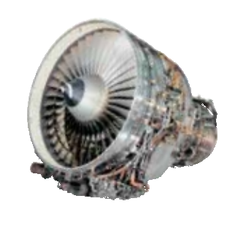
LEAP Courses

LEAP General Familiarization
ATA 104 Level Level I
Prerequisites: None
Course Length: 4 hours
In Class Option: N/A
Virtual Option: 1 day at AEMTC only
This course is available online at the CTEC University website and is a prerequisite to be completed at the student’s home base before attending Line Maintenance. This course is an academic training session designed for personnel who require a general knowledge of the basic engine construction features, airflows, engine systems, and accessories.
Available in the following engine models:
LEAP-1A, LEAP-1B, LEAP-1C

LEAP Powerplant Line & Base Maintenance
ATA 104 Level Level III
Prerequisites: General Familiarization
In Class Option (LEAP-1A/-1B (5 days): Yes
In Class Option (LEAP-1C (6 days): Yes
Virtual Option (3 days): Yes
Class Size: 6-12 students
This course is an academic and practical training session designed for line maintenance mechanics and supervisory personnel with high-bypass engine and English language experience. The course consists of specific academic information on engine airflows, engine systems, component identification, and fault analysis. The hands-on portion of this course consists of removal and replacement of select engine components and use of maintenance manuals.
Available in the following engine models:
LEAP-1A, LEAP-1B, and October 2021 LEAP-1C

*This course must be purchased at the current training rate, or training entitlements may be used at a three times (3X) rate if training entitlements are available to the customer
LEAP Borescope Inspection
ATA 104 Level Level IV
Prerequisites: Basic Borescope
In Class Option (2 day) Yes
Virtual Option N/A
Class Size: 3-6 students
This course provides the information necessary to understand the basic borescope inspection of the engine. This course is recommended for borescope inspectors and quality personnel. The hands-on portion of this course consists of removal and replacement of engine borescope plugs, borescope inspection, and use of maintenance manuals.
Available in the following engine models:
LEAP-1A, LEAP-1B, and October 2021 LEAP-1C

LEAP Engine Change
ATA 104 Level Level IV
Prerequisites: N/A
In Class Option (2 day) Yes
Virtual Option N/A
Class Size: 6-12 students
This course is an academic and practical training session designed to train Line Maintenance personnel how to remove and install a LEAP engine.
Available in the following engine models:
LEAP-1A, LEAP-1B

LEAP Borescope Blade Blend*
ATA 104 Level Level IV
Prerequisites: Borescope Inspection experience
In Class Option (1 day): Yes
Virtual Option: N/A
Class Size: 3-4 students
This course is an academic and practical training session designed for line maintenance technicians and supervisory personnel. Subject matter will include blade blend procedures, use of borescope blend equipment, and application of the maintenance manual for the LEAP-series engines.
Available in the following engine models:
LEAP-1A, LEAP-1B, and October 2021 LEAP-1C

Avionics and Electrical Power Systems

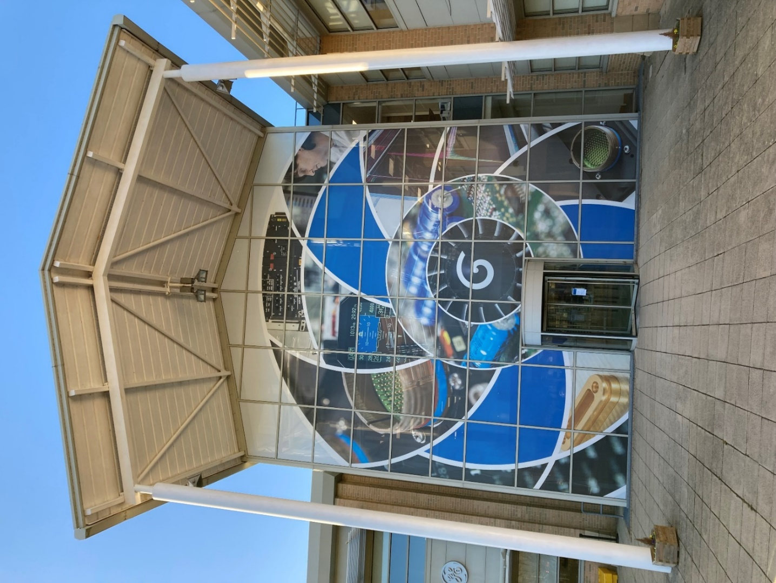

Avionics and Electrical Power Systems

GE Avionics and Electrical Power Systems Training has its headquarters at Cheltenham in the UK; training is available at both the Cheltenham and Cincinnati centers - or by arrangement at the customer’s location if preferred.

GE Aerospace provides world-class Systems and instrument training designed to meet the changing needs of today’s customers with outstanding support. Before every course, the material and information are reviewed to ensure the very latest product updates are included.

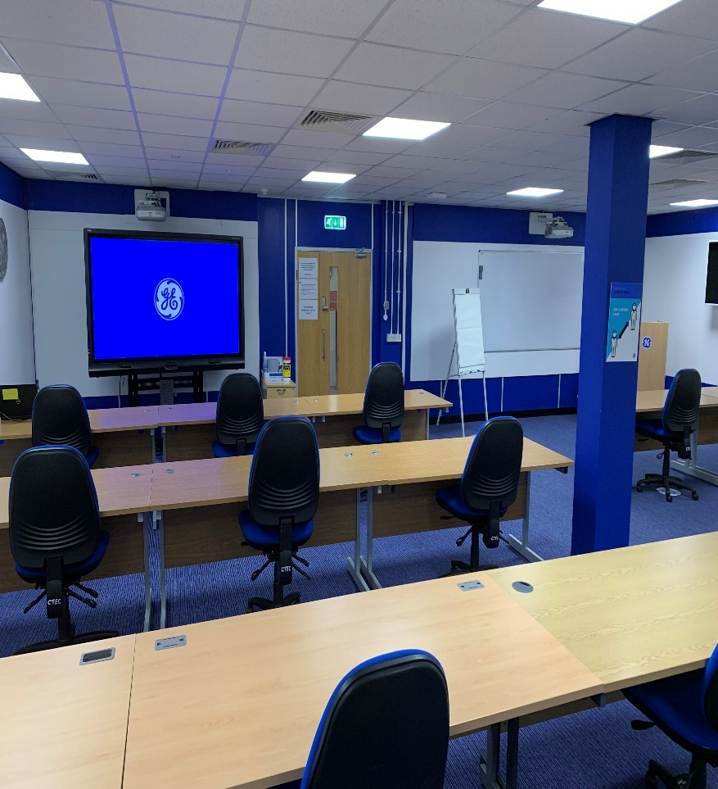

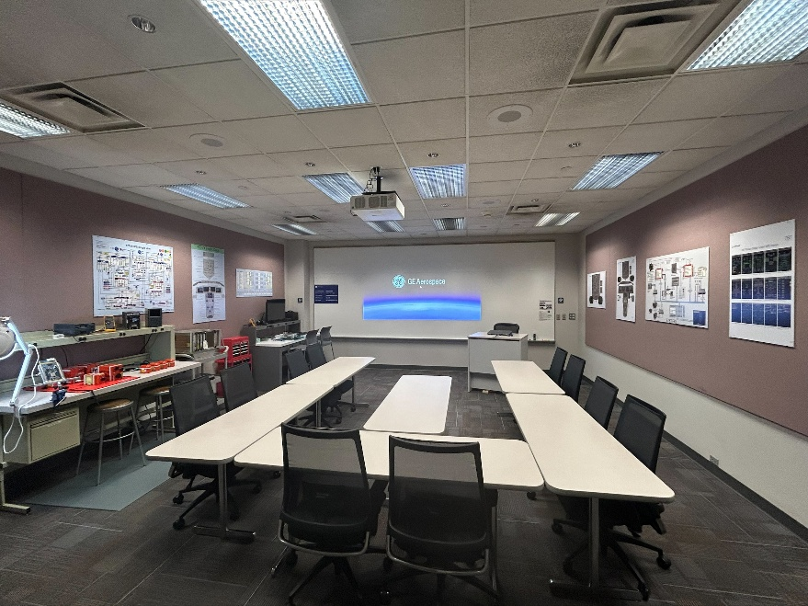

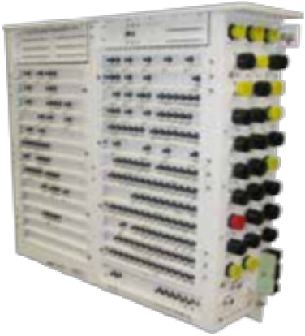

Boeing 777
Electrical Load
Management
System (ELMS)

Fitted to all variants of the Boeing 777, the purpose of the ELMS is to house all the hardware (busbars, contactors, relays and circuit breakers) required for power distribution. ELMS monitors and controls individual loads, provides switching functions necessary to connect and disconnect loads as required and it plays a major role in controlling and supplying power to aircraft systems.

Boeing 777
Electrical Load Management System*

ATA 104 Level Level III
Prerequisites: None
Course Length: 3 days
In Class Option: N/A
Virtual Option: N/A
Class Size 3-12 students
This course is an academic training session designed to provide an understanding of the role of ELMS in power distribution and management for the Boeing 777 aircraft**. The course covers ELMS versions: 1, 2, and PDP 2.5 (based on ATA Specification 104 Guidelines for Aircraft Maintenance Training). All classes will be taught in English.

By the end of the course the student will be able to-

- Describe the Boeing 777 AC and DC power distribution system.
- Describe the role ELMS plays in aircraft power management.
- Describe the location of the various components and how they are controlled and operated.
- Troubleshooting and testing of the system is also included as theoretical training.

Line/Base Engineers and Technicians, FSEs, Technical Support personnel and Engineering Management who need a detailed understanding of the Boeing 777 ELMS will benefit from attending this course.

**ELMS 3 for the 777X aircraft is a separate course offering.

*Systems training entitlements can be used for this course provided they are available to the customer (engine training credits may not be used for this course). Alternatively, training may be purchased at the current training rate. Please contact the Systems Training Manager for details.

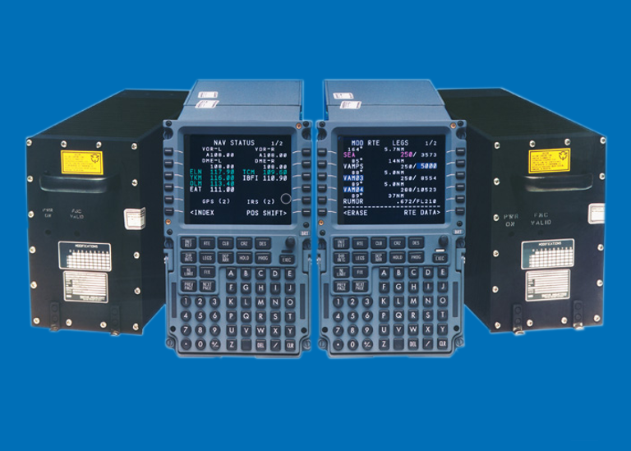Boeing 737
Flight Management
System (FMS)

The Flight Management System is fitted to the 737-300/400/500/600/700/800
+ BBJ series aircraft. Its main function is to generate continuous automatic navigation and guidance, as well as to control and monitor performance. The heart of the system is the Flight Management Computer System, which computes accurate position data and guides the aircraft along a route using the most economical height and speed.

Boeing 737-300/400/500/600/700/800
Flight Management System*

ATA 104 Level Level III
Prerequisites: None
Course Length: 3 days
In Class Option: N/A
Virtual Option: N/A
Class Size 3-12 students
This academic course is designed to provide an understanding of the operation of the FMS fitted to the Boeing 737-300/400/500/600/700/800 + BBJ series aircraft. It covers both single and dual configurations, as well as how to carry out ATA 104 level III maintenance tasks. All classes will be taught in English.

By the end of the course the student will be able to-
- Name the components of the FMS and state their locations in the aircraft.
- List the equipment which interfaces with the system.
- Understand and describe the basic concept, operation, and BIT of the FMS.
- Additional aspects covered by the course are loading/cross loading the various software applications (OFP, MEDB & NDB) and initializing and loading a basic flight plan.

Line/Base Engineers and Technicians, FSEs, Technical Support personnel and Engineering Management who need a detailed understanding of 737 FMS will benefit from attending this course.

*Systems training entitlements can be used for this course provided they are available to the customer (engine training credits may not be used for this course). Alternatively, training may be purchased at the current training rate. Please contact the Systems Training Manager for details.

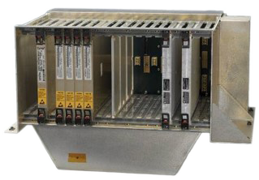

Boeing 787
Common Core System (CCS)

The Common Core System is the future for systems integration. It provides reliable, high speed, real time communication between systems while also delivering lower operating costs, reduced fuel consumption and reduced maintenance costs.

Boeing 787 Common Core System*

ATA 104 Level Level III
Prerequisites: None
Course Length: 3 days
In Class Option: N/A
Virtual Option: N/A
Class Size 3-12 students
This is an academic training course designed to give an understanding of the Boeing 787 CCS, how it differs from a legacy federated architecture system and how the different systems utilize a common computing resource. ATA 104 level III servicing tasks are covered. All classes will be taught in English.

By the end of the course, the student will be able to-
- Describe the concept and operation of the CCS and its individual LRUs.
- Understand the System Support Functions within the CCS, as well as the Maintenance terminal and displays.

Line/Base Engineers and Technicians, FSEs, Technical Support personnel and Engineering Management who need a detailed understanding of the 787 CCS will benefit from attending this course.

*Systems training entitlements can be used for this course provided they are available to the customer (engine training credits may not be used for this course). Alternatively, training may be purchased at the current training rate. Please contact the Systems Training Manager for details.

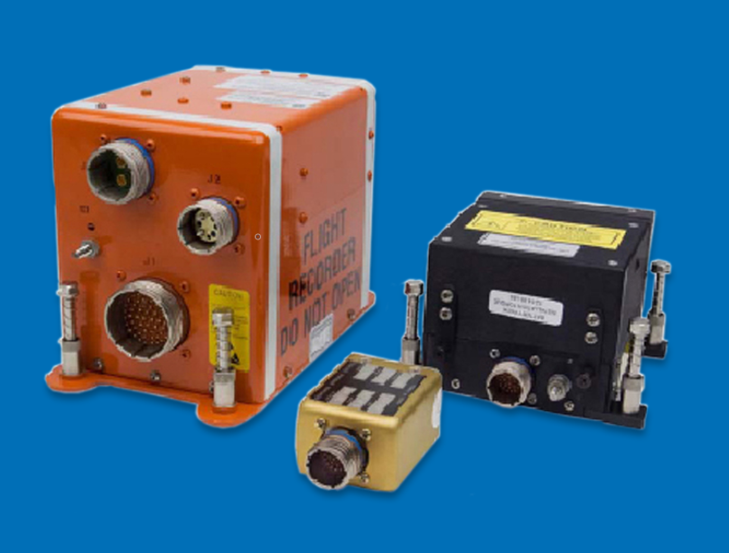

Boeing 787 EAFR,
RIPS & AMP

The recording Subsystem on the Boeing 787 is heavily integrated into the CCS and combines the Flight Data Recording with the voice and audio recording systems.

Boeing 787 Recording Subsystem
(including the EAFR, RIPS, and AMP)*

ATA 104 Level Level III
Prerequisites: None
Course Length: 1 day
In Class Option: N/A
Virtual Option: N/A
Class Size 3-12 students
Normally delivered in conjunction with the 787 CCS course, this is an ATA level III academic session designed to provide an understanding of the Boeing 787 Recording Subsystem, in particular the Enhanced Airborne Flight Recorder, its component parts and supporting software tools.

After completing this course, the student will be able to-
- Describe the purpose and operation of the Recording Subsystem component parts and their operation.
- Outline the use of the maintenance terminal as applicable to the recording Subsystem.
- Will have received an outline of the EAFR Ground Based Tool. All classes will be taught in English.

Line/Base Engineers and Technicians, FSEs, Technical Support personnel and Engineering Management who need a detailed understanding of the 787 Recording Subsystem will benefit from attending this course.

NOTE: Because this course is normally delivered in conjunction with the 787 CCS course, it should only be considered as a standalone option if the students have already attended the 787 CCS course.

For a course specific to the Ground Based Tool (Integrated Ground Software), please contact the GE Aerospace Systems Training Manager.

*Systems training entitlements can be used for this course provided they are available to the customer (engine training credits may not be used for this course). Alternatively, training may be purchased at the current training rate. Please contact the Systems Training Manager for details.

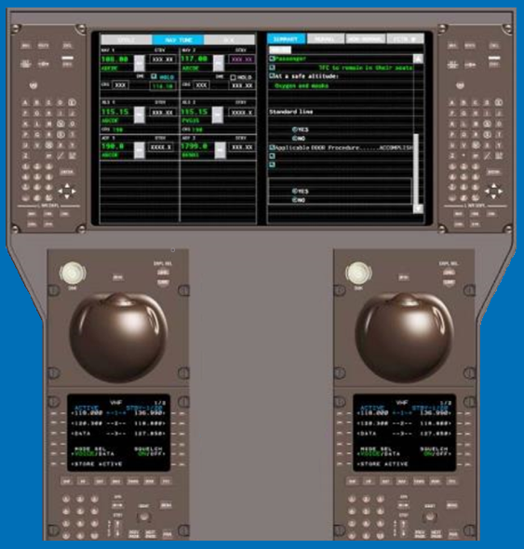

COMAC 919
Flight Management System

The COMAC 919 Flight Management System (FMS), developed by GE Aerospace Systems combines the COMAC 919 aircraft avionics capabilities to ease workload of the aircrew and allow them more time to safely managing the aircraft. The FMS provides multi-sensor navigation, flight planning, trajectory prediction, and performance calculations. Its main function is to generate continuous automatic navigation and guidance to guide the aircraft along a route using the most economical altitude and speed.

COMAC 919 Flight Management System (FMS)

ATA 104 Level Level III
Prerequisites: None
Course Length: 3 days
In Class Option: N/A
Virtual Option: N/A
Class Size 3-12 students
This academic course is designed to provide an understanding of the COMAC 919-Flight Management System (FMS).

This course explains the differences between a legacy federated architecture system and how the COMAC 919 utilizes an Integrated Modular Avionics (IMA) environment. It covers how to carry out ATA 104 level III maintenance tasks. All classes will be taught in English.

By the end of the course, the student will be able to-
- Understand the full functionality of the COMAC 919 FMS and how it operates in the IMA environment.
- Be knowledgeable of the system components and system interfaces as well as control devices and user interfaces.
- Understand and describe the basic concept, and operation of the FMS.

Line/Base Engineers and Technicians, FSEs, Technical Support personnel and Engineering Management who need a detailed understanding of COMAC 919 FMS will benefit from attending this course.

*Systems training entitlements can be used for this course provided they are available to the customer (engine training credits may not be used for this course). Alternatively, training may be purchased at the current training rate. Please contact the Systems Training Manager for details.

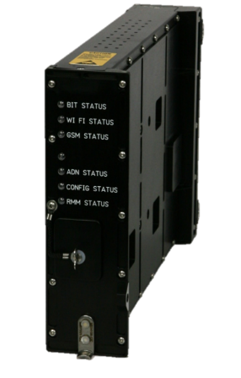

COMAC 919
Onboard
Maintenance System (OMS)

The OMS is the system responsible for monitoring the overall health of the aircraft and maintenance data published by the various aircraft systems. t’s overall function is to provide fault localization and diagnostic assessment on the health of the avionic systems on the aircraft and communicate faults and events, using appropriate methods of transmittal and displays.

COMAC 919 Onboard Maintenance System*

ATA 104 Level Level III
Prerequisites: None
Course Length: 3 days
In Class Option: N/A
Virtual Option: N/A
Class Size 3-12 students
This course is an academic training session designed to give an understanding of the COMAC 919 Onboard Maintenance System (OMS). ATA 104 level III servicing tasks are covered. All classes will be taught in English.

At the end of the course the student will be able to:

- Describe the general description and overview of the OMS.
- State the basic function of the aircraft OMS.
- Describe the features and functional architecture of the OMS.
- Describe the OMS interfaces.
- Describe the operation of the OMS.
- Describe description, function and process for data loading and SD backup.
- Describe the OMS Modes of operation.

Line/Base Engineers and Technicians, FSEs, Technical Support personnel and Engineering Management who need a detailed understanding of the COMAC 919 OMS will benefit from attending this course.

*Systems training entitlements can be used for this course provided they are available to the customer (engine training credits may not be used for this course). Alternatively, training may be purchased at the current training rate. Please contact the Systems Training Manager for details.

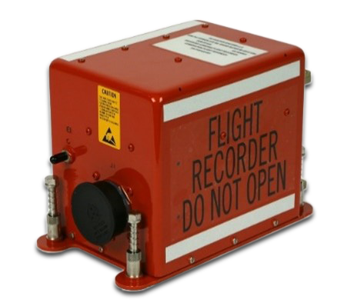

COMAC 919
Flight Recording System (FRS)

The FRS on the COMAC 919 interfaces with other aircraft systems to satisfy regulatory requirements for the Flight Data Recorder and Cockpit Voice Recorder, including requirements for Communication, Navigation and Surveillance/Air Traffic Management (CNS/ATM) Data-link communication recording.

COMAC 919 Flight Recording System
(Including the EAFR, RIPS, and AMP)*

ATA 104 Level Level III
Prerequisites: None
Course Length: 1 day
In Class Option: N/A
Virtual Option: N/A
Class Size 3-12 students
This course is an ATA level III academic session designed to provide an understanding of the COMAC 919 Recording Subsystem, in particular the Enhanced Airborne Flight Recorder (EAFR), its component parts and supporting software tools. All classes will be taught in English.

After completing this course, the student will be able to-
- Describe the purpose and operation of the Recording Subsystem component parts and their operation.
- Outline the use of the maintenance terminal as applicable to the recording Subsystem.
- Will have received an outline of the EAFR Ground Based Tool.

Line/Base Engineers and Technicians, FSEs, Technical Support personnel and Engineering Management who need a detailed understanding of the COMAC 919 Recording Subsystem will benefit from attending this course.

*Systems training entitlements can be used for this course provided they are available to the customer (engine training credits may not be used for this course). Alternatively, training may be purchased at the current training rate. Please contact the Systems Training Manager for details.

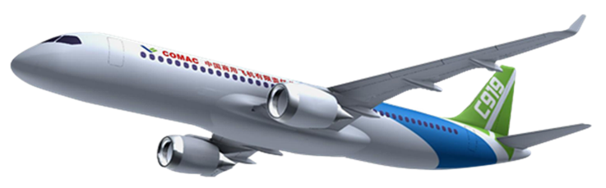

COMAC 919
FMS / FRS / OMS
Level 1

This course is designed provide a trained person with first line level system knowledge of the Onboard Maintenance System (OMS), Flight Recording System (FRS) and Flight Management System (FMS) fitted to the COMAC C919 aircraft.

COMAC 919 Flight Management System, Flight Recording System (FRS), and Onboard Maintenance System (OMS)*
Level 1

ATA 104 Level Level I
Prerequisites: None
Course Length: 1.5 days
In Class Option: N/A
Virtual Option: N/A
Class Size 3-12 students
This course is an academic training session designed to provide a general understanding and the system knowledge of the OMS, FRS and FMS systems fitted to the COMAC C919 aircraft. Training is based on ATA 104 Guidelines for Aircraft Maintenance Training. All classes will be taught in English.

By the end of the course the student will be able to-
- Describe the basic function, purpose, component locations, basic operations, of the FMS, FRS, and OMS systems.

Line/Base Engineers and Technicians, FSEs, Technical Support personnel and Engineering Management who need a general understanding of the COMAC 919 FMS, FRS and OMS will benefit from attending this course.

*Systems training entitlements can be used for this course provided they are available to the customer (engine training credits may not be used for this course). Alternatively, training may be purchased at the current training rate. Please contact the Systems Training Manager for details.

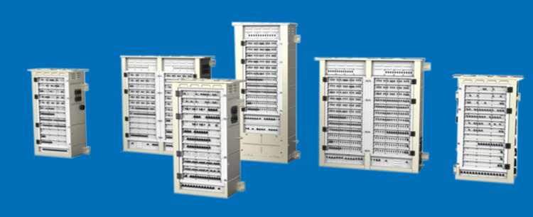

Electrical Load
Management
System (ELMS 3)

Designed for the Boeing 777X, the purpose of the ELMS 3 is to house all the hardware (busbars, contactors, relays and circuit breakers) required for power distribution. ELMS monitors and controls individual loads, provides switching functions necessary to connect and disconnect loads as required and it plays a major role in controlling and supplying power to aircraft systems.

Boeing 777X
Electrical Load Management System 3*

ATA 104 Level Level III
Prerequisites: None
Course Length: 3 days
In Class Option: N/A
Virtual Option: N/A
Class Size 3-12 students
This course is an academic training session designed to provide an understanding of the role of ELMS 3 in power distribution and management for the Boeing 777X aircraft. The ELMS 3 course is based on ATA Specification 104 Guidelines for Aircraft Maintenance Training. All classes will be taught in English.

By the end of the course the student will be able to-
- Describe the Boeing 777X AC and DC power distribution system.
- Describe the role ELMS 3 plays in the Boeing 777X aircraft power management.
- Describe the location of the various components and how they are controlled and operated.
- Troubleshooting and testing of the system is also included as theoretical training.

Line/Base Engineers and Technicians, FSEs, Technical Support personnel and Engineering Management who need a detailed understanding of Boing 777X ELMS 3 will benefit from attending this course.

*Systems training entitlements can be used for this course provided they are available to the customer (engine training credits may not be used for this course). Alternatively, training may be purchased at the current training rate. Please contact the Systems Training Manager for details.

Boeing 777X
Common Core System
(CCS)

The Boeing 777X Common Core System uses fewer components than previous systems and is the future for systems integration. It provides reliable, high speed, real-time communication between systems while also delivering lower operating costs, reduced fuel consumption and reduced maintenance costs.

Boeing 777X Common Core System*

ATA 104 Level Level III
Prerequisites: None
Course Length: 3 days
In Class Option: N/A
Virtual Option: N/A
Class Size 3-12 students
This is an academic training session designed to give an understanding of the Boeing 777X CCS, how it differs from a legacy federated architecture system and how the different systems utilize a common computing resource. ATA 104 level III servicing tasks are covered. All classes will be taught in English.

By the end of the course, the student will be able to -
- Describe the concept and operation of the Boeing 777X CCS and its individual LRUs.
- Will understand the System Support Functions within the CCS, as well as the Maintenance terminal and displays.

Line/Base Engineers and Technicians, FSEs, Technical Support personnel and Engineering Management who need a detailed understanding of the Boeing 777X CCS will benefit from attending this course.

*Systems training entitlements can be used for this course provided they are available to the customer (engine training credits may not be used for this course). Alternatively, training may be purchased at the current training rate. Please contact the Systems Training Manager for details.

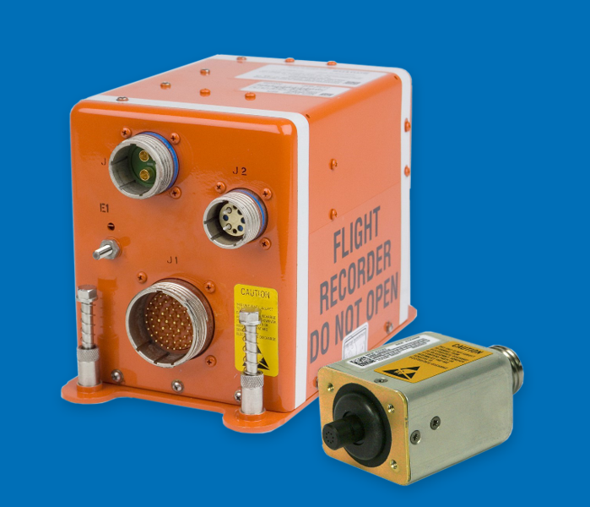

Boeing 777X
Flight Recording
System

The recording Sub system on the Boeing 777X gathers and stores airplane parameters and system data in a protected solid-state memory. These parameters provide data on flight conditions and airplane systems operation. Airline personnel use the data to analyze system performance during airplane maintenance.

Boeing 777X Recording Subsystem
(including the EAFR and AMP)*

ATA 104 Level Level III
Prerequisites: None
Course Length: 1 day
In Class Option: N/A
Virtual Option: N/A
Class Size 3-12 students
Normally delivered in conjunction with the 777X CCS course, this is an ATA level III academic session designed to provide an understanding of the Boeing 787 Recording Subsystem, in particular the Enhanced Airborne Flight Recorder, its component parts and supporting software tools. All classes will be taught in English.

After completing this course, the student will be able to
- Describe the purpose and operation of the Recording Subsystem component parts and their operation.
- Outline the use of the maintenance terminal as applicable to the recording Subsystem and will have received an outline of the EAFR Ground Based Tool.

Line/Base Engineers and Technicians, FSEs, Technical Support personnel and Engineering Management who need a detailed understanding of the Boeing 777X Recording Subsystem will benefit from attending this course.

NOTE: Because this course is normally delivered in conjunction with the Boeing 777X CCS course, it should only be considered as a standalone option if the students have already attended the Boeing 777X CCS course.

For a course specific to the Ground Based Tool (Integrated Ground Software), please contact the GE Aerospace Systems Training Manager

*Systems training entitlements can be used for this course provided they are available to the customer (engine training credits may not be used for this course). Alternatively, training may be purchased at the current training rate. Please contact the Systems Training Manager for details.

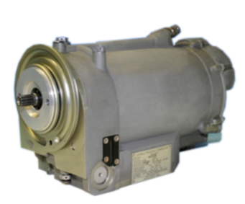
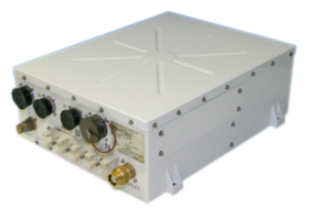

Boeing 777X
Backup Electrical
Power System
(includes BUC and
BUG)

The Boeing 777X Backup Electrical Power System (BEPS) is a non-time limited power source for essential airplane loads connected to the Transfer Buses in the event of loss of power to one or both Main AC Buses.

Boeing 777X Backup Electrical Power System*

ATA 104 Level Level III
Prerequisites: None
Course Length: 1 day
In Class Option: N/A
Virtual Option: N/A
Class Size 3-12 students
This is an academic training session designed to give an understanding of the Boeing 777X Backup Electrical System (BEPS). ATA 104 level III servicing tasks are covered. All classes will be taught in English.

By the end of the course, the student will be able to –
- Describe the concept and operation of the Boeing 777X BEPS and its individual LRUs.
- A full functional description of BEPS capabilities and operation will be taught.
- The B777-9 BEPS course provides context for the functions and the analysis of failure conditions, and the meaning of maintenance displays.

Line/Base Engineers and Technicians, FSEs, Technical Support personnel and Engineering Management who need a detailed understanding of the Boeing 777X BEPS will benefit from attending this course.

*Systems training entitlements can be used for this course provided they are available to the customer (engine training credits may not be used for this course). Alternatively, training may be purchased at the current training rate. Please contact the Systems Training Manager for details.

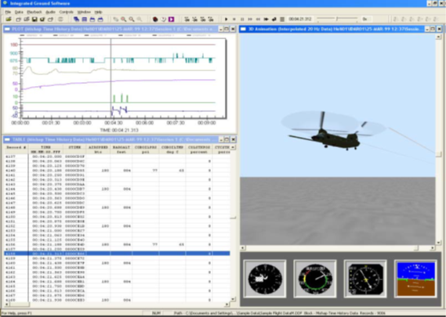
Boeing 777X & 787 Integrated Ground System (IGS)

To enable trained person to carry out Level 4 (ATA 104) analysis of flight data and voice files from the B777X and B787 Enhanced Airborne Flight Recorder (EAFR) through the use of the Integrated Ground Systems (IGS) Software.

Boeing 787 Integrated Ground Systems*

ATA 104 Level Level IV
Prerequisites: B787 CCS, EAFR L3
Course Length: 3 days (18 hrs)
In Class Option: N/A
Virtual Option: N/A
Class Size 3-6 students
This course is an is an ATA Level IV academic session designed to provide an understanding of the GE Integrated Ground System (IGS) installed on the B787 and B777X aircraft. A review of the Common Core and Flight Recording System is built into this course. All classes will be taught in English.

After completing this course, the student will be able to:
- State the basic function of the B787 Common Core System (CCS)
- Describe the purpose of the component parts of the Recording Subsystem
- Describe the basic operation and location of the EAFR
- Describe how the status of the Recording Subsystem is communicated to ground crew
- Outline the use of the Maintenance Terminal with regard to the Recording Subsystem
- Describe the basic operation and location of the RIPS and AMP
- Outline the use of EAFR Ground Based Tools
- State the purpose and function of the basic IGS Window Structure
- Describe how to import Flight Data
- Describe how to Import and Play Voice Data
- Describe how to Export Data and Audio Information
- Describe how to perform a Data Search
- Describe how to Setup and Play 3D Animation
- Describe how to use the Command Line Interface

Military Products Training

CTEC Avionics and Electrical Power Systems can provide a variety of Military Systems training, depending on the product and nation for which it was developed.

Courses vary from 3 days to 5 weeks in length.

If you qualify for military product training, please contact our Systems Training Team for further information and pricing details.
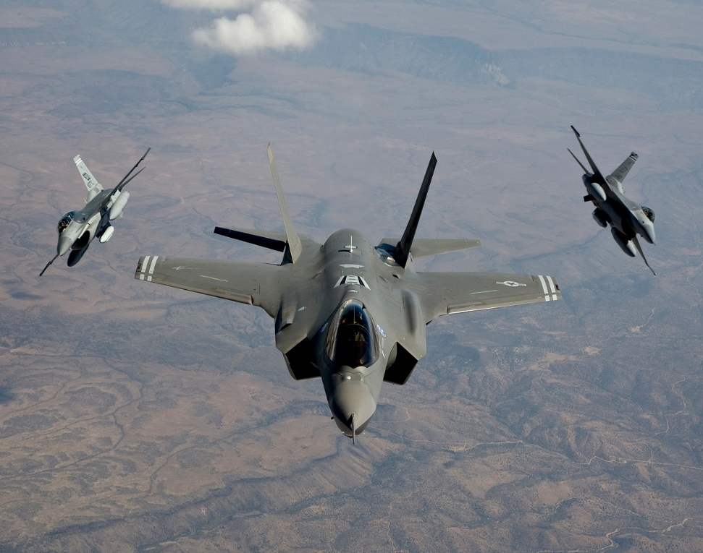



Contact Information

Customer Technical Education Center (CTEC)
123 Merchant Street
Cincinnati, OH 45246
T +1.513.552.6692
F +1.513.552.2777
Email: ctec.u@geaerospace.com

CTEC University (CTEC U)
https://training.geaerospace.com/

GE Aerospace Fleet Support
1.877.432.3272 (U.S.) or
+1.513.552.3272 (international)
aviation.fleetsupport@geaerospace.com (Cincinnati)
aviation.fleetsupport.cn@geaerospace.com (Shanghai)

Customer Portals
GE Aerospace: my.geaerospace.com
CFM: mycfmportal.com
GE Honda: mygehonda.com

AEMTC Training Center
East Campus of Civil Aviation Flight University of China
No.46, Section 4, Nanchang Road, Guanghan City
Sichuan Province, China 618307
Telephone: 86-838-5183450
Email: training@aemtc.com

ATRC Training Center
Al Gharrafa Street
Al Rayyan,Education City Advanced Technology & Research Center
Doha, DA, NA, QA
Email: ctec.geaerospace.com

Cheltenham Aviation Systems Training Center
GE Aviation, Bishops Cleeve, Cheltenham
GL52 8SF
T: +44 (0) 75000 78783
Email: ctec.systems@GE.com

